**EXPERIMENT 8**

**SAILOR BOAT DATABASE (DDL, DML, DQL, Subquery, Joins, Set operations)**

**Aim:**

* Create sailors, boats, and reserves.(foreign key)
* Insert 5 values each table.
* Display all records.
* Find the names and ages of all sailors.
* Find all sailors with ratings above 8.
* Find sailors name with rating above 7 & age above 25.
* Display all the names & colors of the boats.
* Find all the boats with Red colors.
* Find the names of sailors' who have reserved boat number 103.
* Find the sids of sailors who have reserved blue boat
* Find the names of sailors' who have reserved Red boat.
* Find the colours of boats reserved by some name(provide any name in table).
* Find the names of the sailors who have reserved at least one boat.
* Find the names of the sailors who have reserved two different boats.
* Find the names of sailors who have reserved a Red or a Green boat.(union)
* Find the names of sailors who have reserved both a Red and a Green boat.
* Find the names of sailors who have reserved boat 103.(nested query)
* Find the names of sailors who have reserved red boat.(nq)
* Find the names of sailors who have not reserved red boat.(nq)
* Find the names of sailors who have reserved boat number 103.(exists)
* Find sailors whose rating is better than some sailors called name.
* Find sailors whose rating is better than every sailor' called name.
* Find the sailors with highest rating.
* Find the average age of all sailors.
* Find the average age of sailors with a rating of 10.
* Count the number of sailors.
* Count the number of different sailor ratings.
* Find the name and age of the oldest sailor.
* Find the names of the sailors who are older than the oldest sailor with a rating of 10.
* Find the age of youngest sailor for each rating level.
* Find the age of the youngest sailor who is eligible to vote (i.e., is at least 18 years old) for each rating level with at least two such sailors.
* For each red boat, find the number of reservations for this boat.
* Find all sailors name according to names.
* Find all sailors details according to rating.
* Find all sailors details according to rating(highest first) if ratings are same then according to age(youngest first).

**Code (1 – 7 queries):**

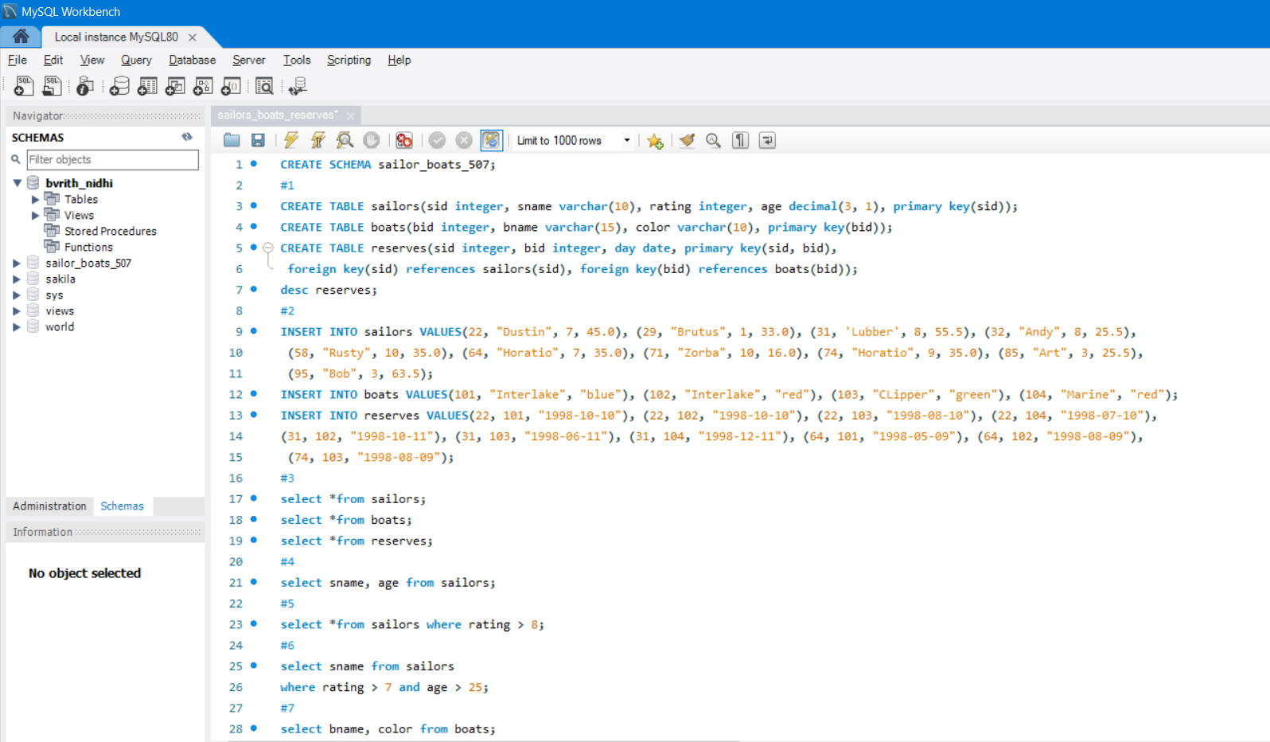

**Output:**

1. Reserves desc

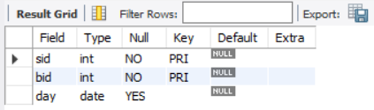

3. Boats table 3. Sailors table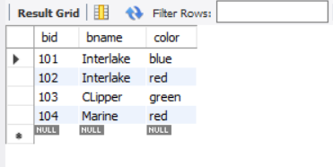 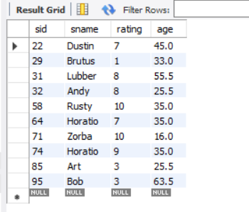

3. Reserves table

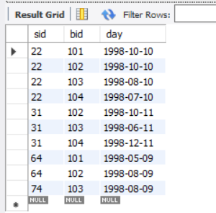

4. sname, age from sailors 5. sailors whose rating is 6. sname from sailors whose age lie

greater than 8 in b/w 7 and 25

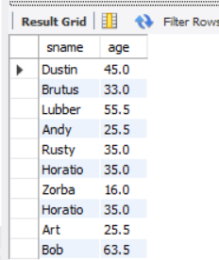 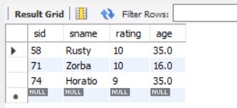 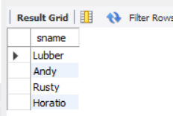

7. Boat name, color from boats

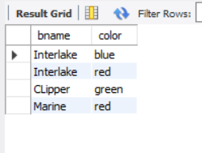

**Code (8 – 18 queries):**

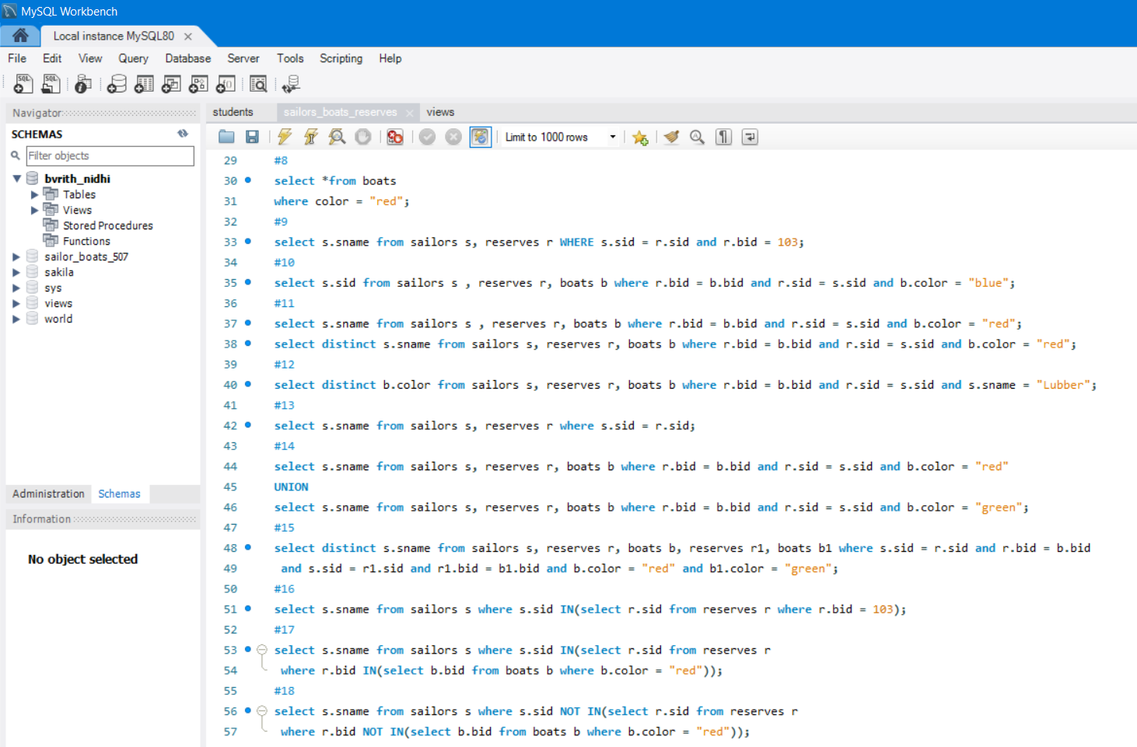

**Output:**

8. Boats with red colour 9. Sailors who reserved 10. 10 sids of sailors who boat number 103 reserved blue boat

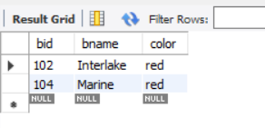 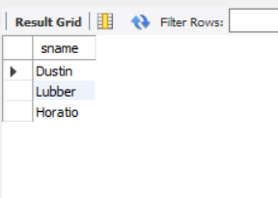 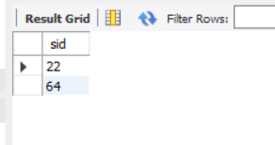

11. sailors who reserved 11. Same query with 12. colors of boats reserved by

red boat distinct names Lubber

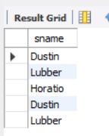 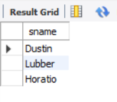 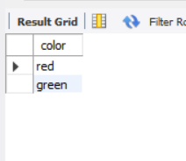

13. sailors who reserved 14. sailors who have reserved 15. sailors who have reserved atleast 1 boat a red or green boat a red and green boat

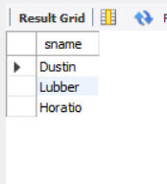 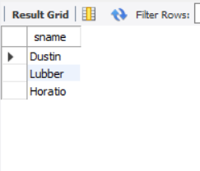 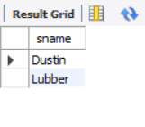

*** Nested query = nq ***

16. sailors who reserved boat 103 17. sailors who have reserved 18 sailors who have not

(nq) red boat (nq) reserved red boat (nq)

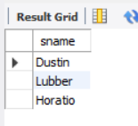 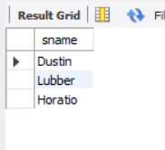 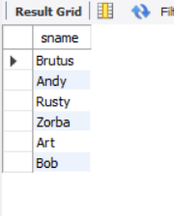

**Code (19 - 32 Queries):**

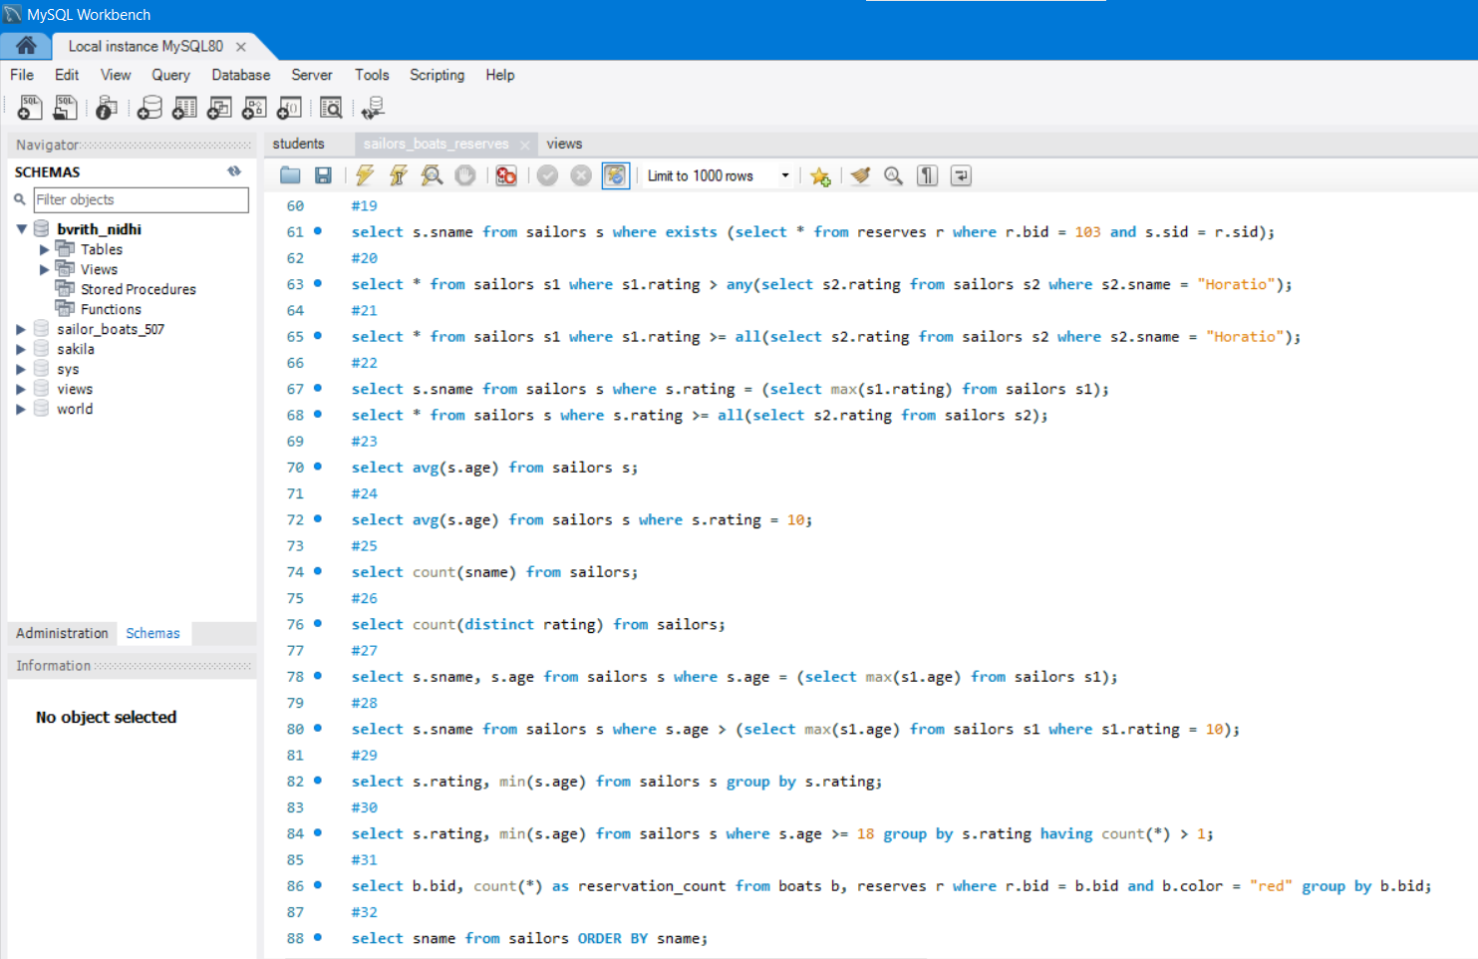

**Output:**

19. sailors who reserved boat 20. sailors whose rating is better 21. sailors whose rating is better

103 (using exists) than sailor called Horatio than every sailor called Horatio

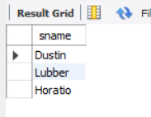 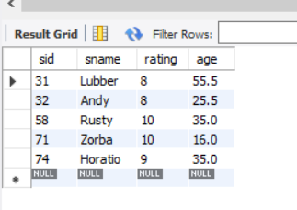 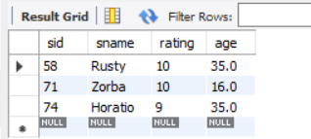

22. sailors with highest rating 23. average age of sailors 24. average age of sailors with

a rating of 10

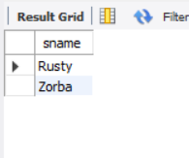 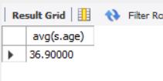 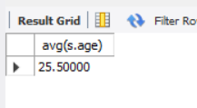

25. number of sailors 26. number of different sailor ratings 27. name and age of oldest sailor

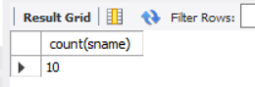 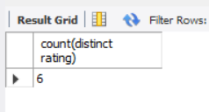 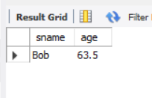

28. sailors who are older than the 29. youngest sailor for each 30. youngest sailor who is eligible to vote

oldest sailor with a rating of 10 rating level for each rating level with at least 2 such

sailors

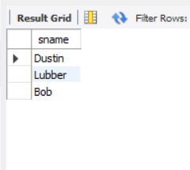 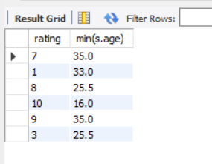 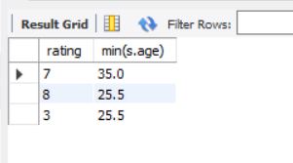

31. For each red boat, number of reservations

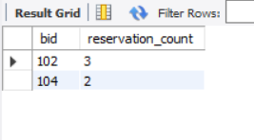

32. sailors names in order

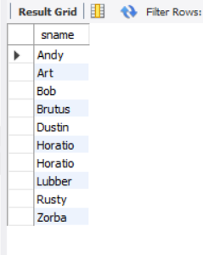

**Code (Queries 33, 34):**

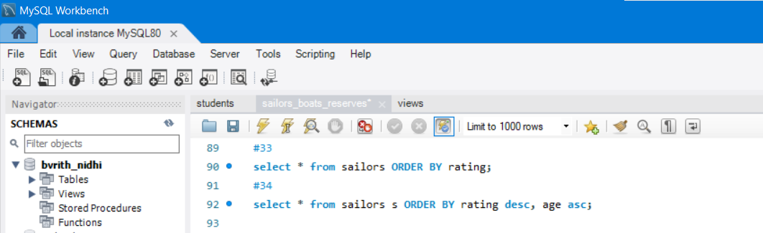

**Output:**

33. sailors details according to rating

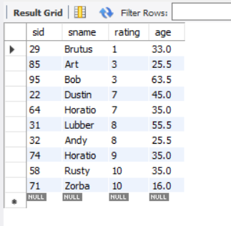

34. sailors details according to rating (highest first), if ratings are same then according to age (youngest first)

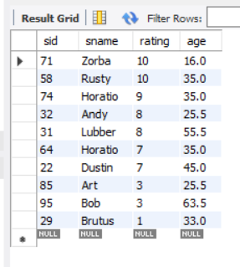

**Code :**

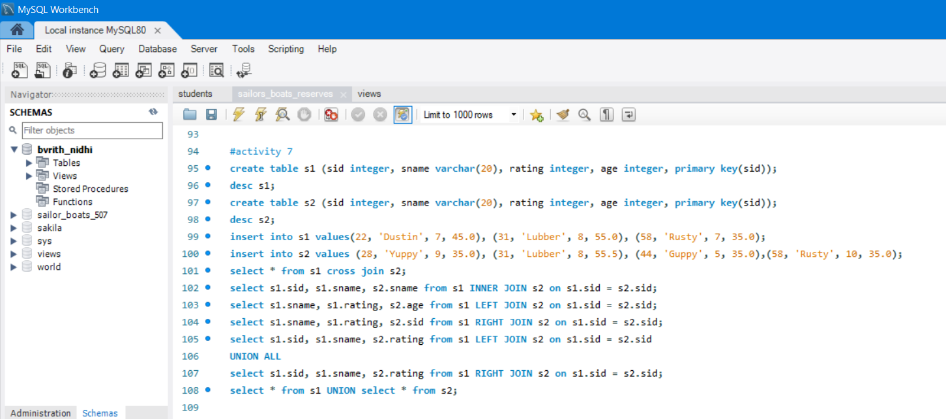

**Output:**

1. Create tables s1, s2 and display them

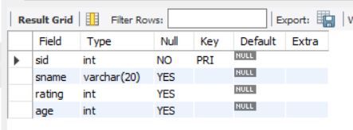 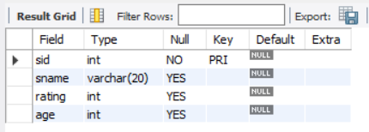

3. Displaying values in a single table using cross join

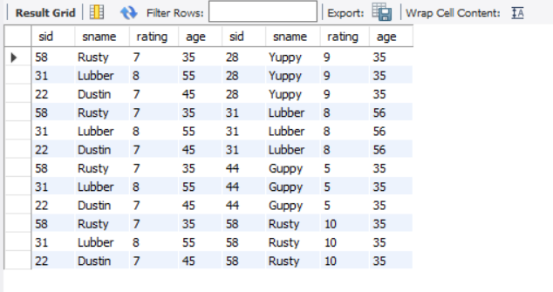

4. Apply inner join on the tables 5. Apply left join on the tables

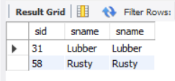 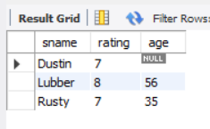

6. Apply right join on the tables 7. Apply union all on the tables 8. Apply union on the tables

